My project- this is custom object detection model it detects only that things that it is trained for .(Not regression model)

collecting images for my training and testing data set using Open CV

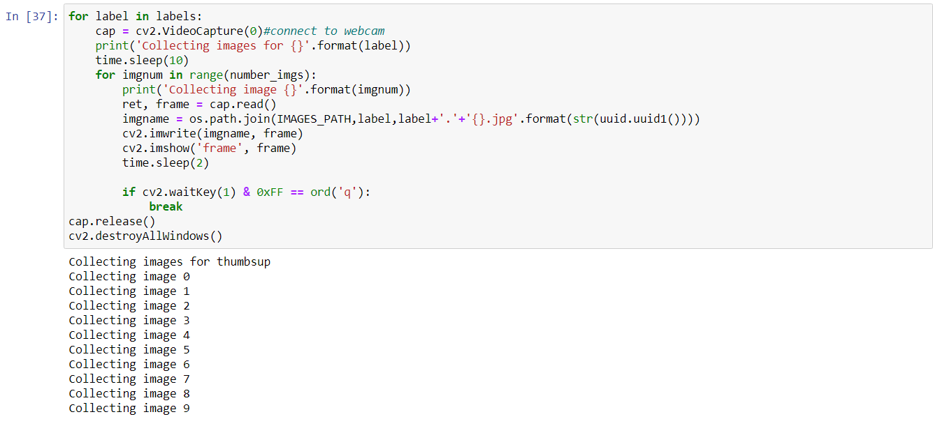

After that I label my images using labeling.py

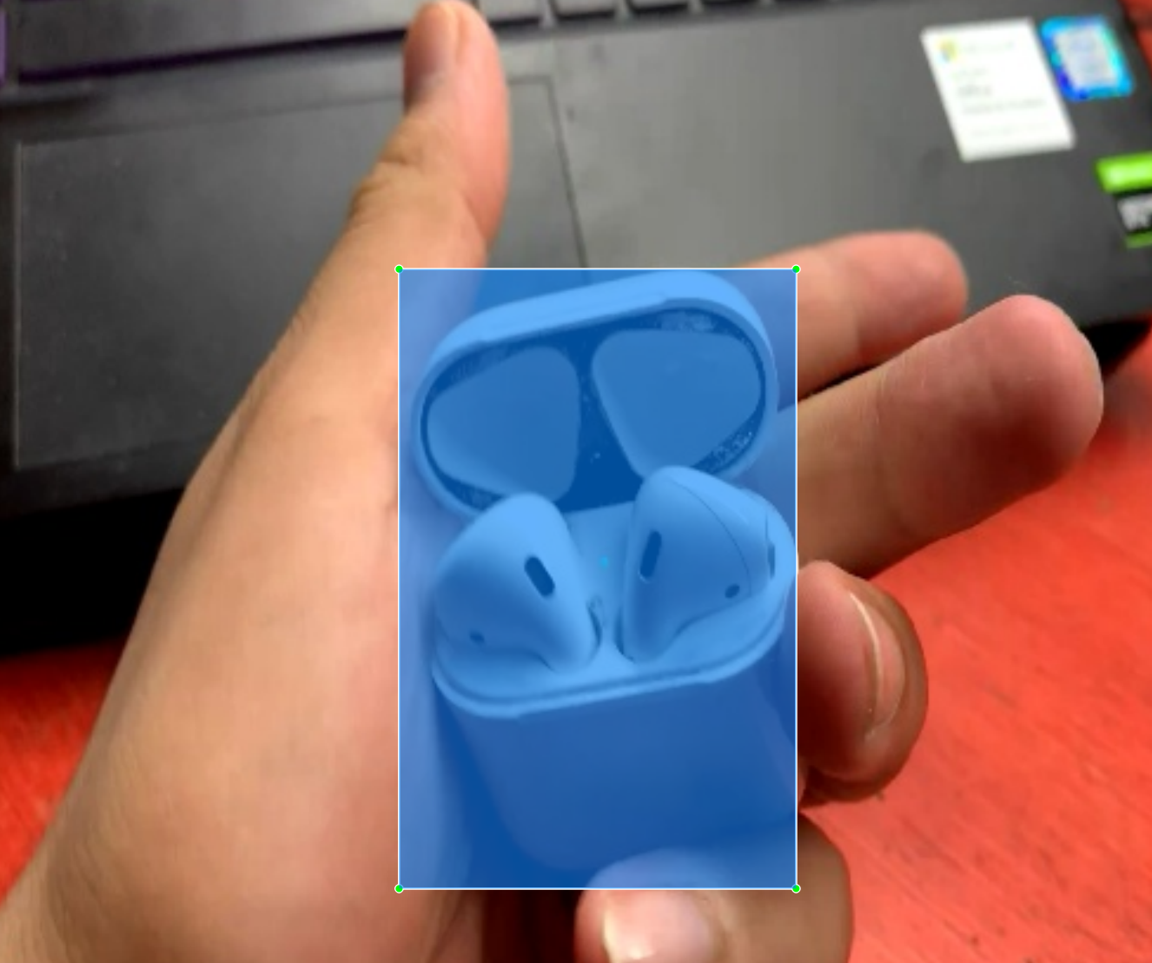

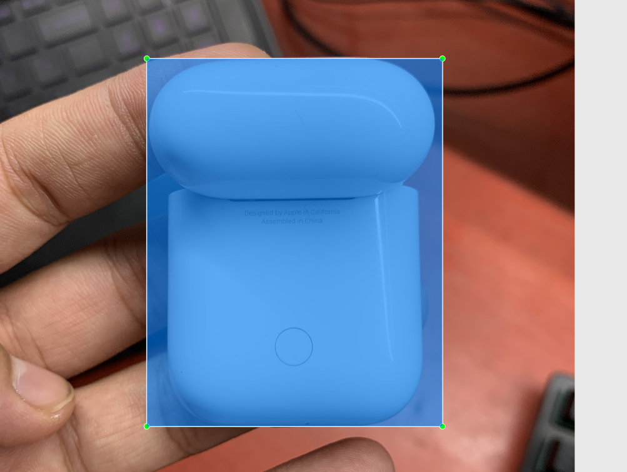

After that I setup paths and install SSD MobileNet V2 FPNLite 320x320 from TensorFlow 2 Detection Model Zoo.

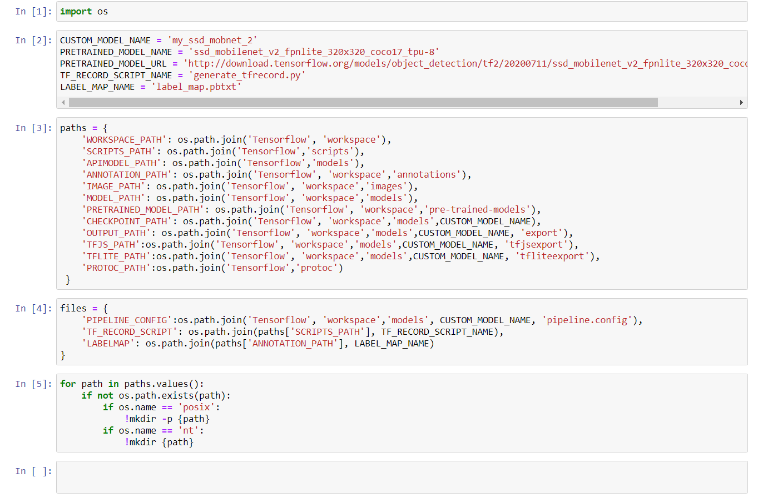

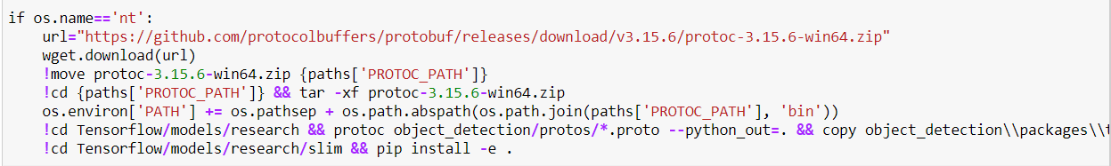

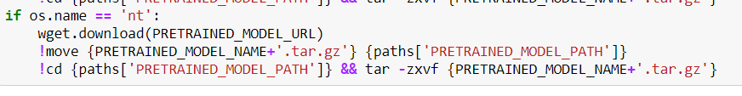

Then after created my labels and using transfer learning updated the object detection model for my custom object detection.

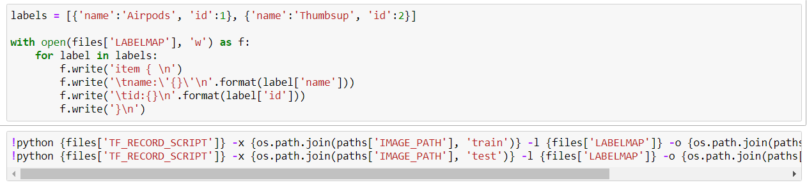

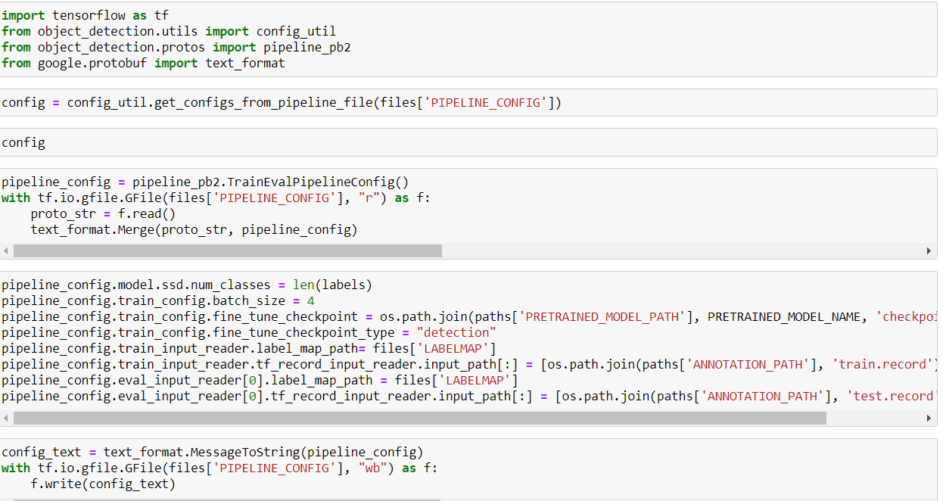

Once this was done, I finally trained and evaluated my model for my custom object.

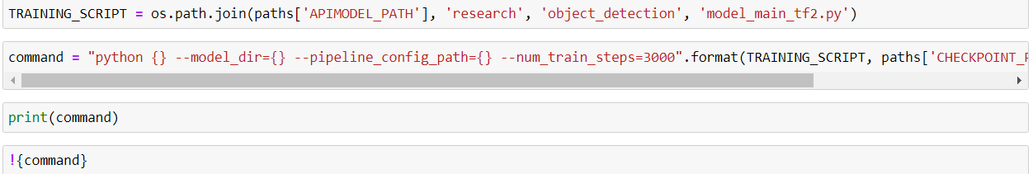

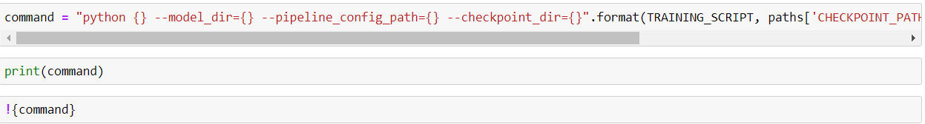

Finally, I tested my model with a testing image and the object got detected with a good precision value.

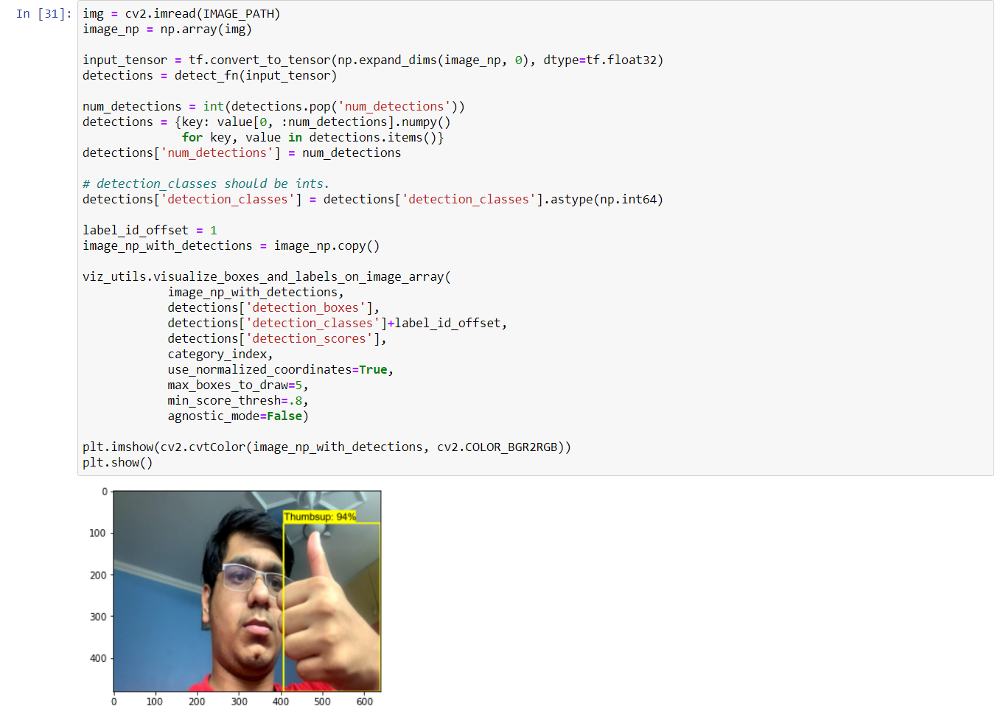

Then I did some real time detection using Open CV module and the result were quite good.

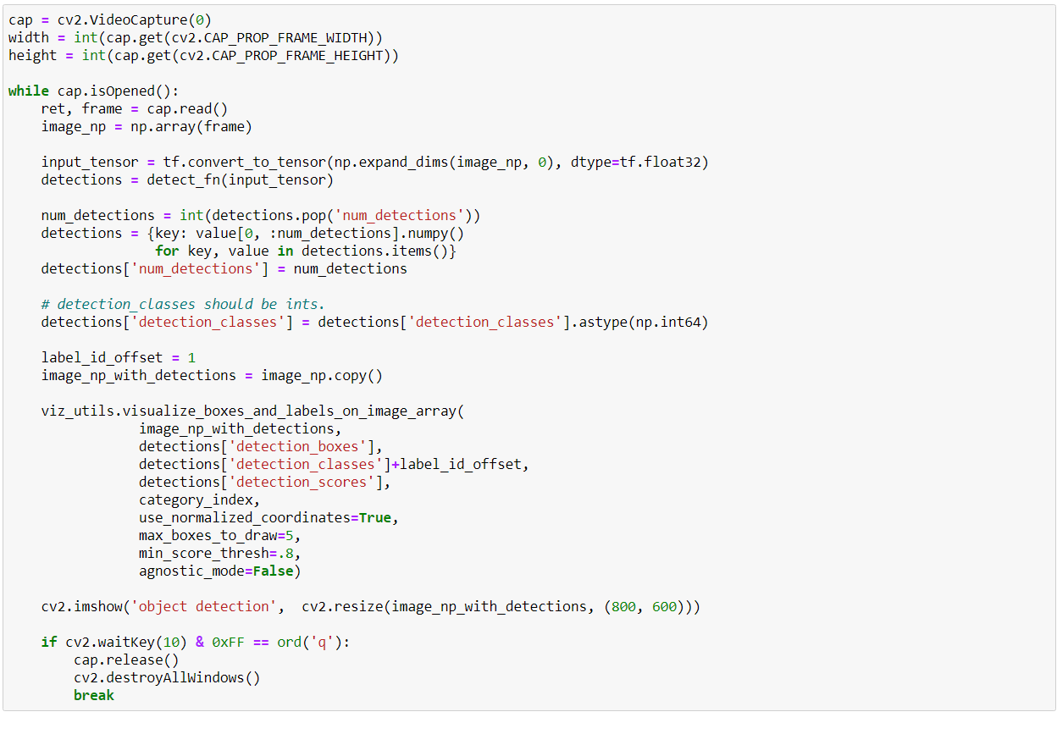

* + Real time object detection result-:

